Ashrafi Siddika

ashrafisiddika738@gmail.com

67/1, Bosila Modha Para, Bosila

Mohammadpur, Dhaka-1207

February 21, 2024

Head of HR

RBS Tech LTD

23/A, Gulshan Avenue,

Dhaka-1212

Dear Hiring Manager,

I am thrilled to submit my application for the IT Project Manager position at RBS LTD, as advertised on <https://rbs.com.bd/>.With Two years of experience in web development and project management, I possess a strong understanding of the full project lifecycle, team leadership, and technical expertise.

My previous role at Ernest & Young LLP as a web Designer and Developer allowed me to lead 2 critical Projects such as LICT. In this role, I learned how to maintain a project budget, set achievable goals, and gained the ability to deliver projects on time. I am comfortable working independently but pride myself on my teamwork and communication abilities. Other key skills include my sense of organization, and SEO analysis, all of which I feel, could benefit your project and help to make me the right fit for the role.

RBS Tech LTD is committed to working on some unique projects focusing on innovation that always inspires me. Seeing your last few projects, made me think that joining your company and working with your team deeply aligns with my values and career aspirations. Therefore, I am highly motivated to work at RBS Tech LTD and contribute my skills to your amazing team.

Thank you for reviewing my application. I am eager to learn more about this exciting opportunity. Please find my resume attached for your consideration. I look forward to hearing from you soon.

Sincerely,

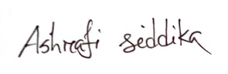

………………………

(Ashrafi Siddika )

|  |  |
| --- | --- |
| 2022-03-  2024-01 | **Ernst &Young LLP**(107/7,block#C,Gulshan Avenue,Dhaka-1)  **Web Developer**   * Planned website development, converting mockups into usable web presence with HTML, and JavaScript. |
| 2021-04-  2021-09 | **Intrigue IT Solution**(Rayer Bazer ,Dhanmondhi, Dhaka-1209)  **Assistant Project Manager**   * Drafted assemblies, models, and other technical drawings. |

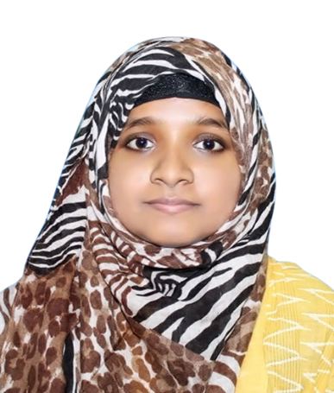

**Work History**

A passionate student pursuing Computer Science and Engineering (CSE). Known for my relentless work ethic and innate ability to quickly grasp new concepts. In my life in the light of honesty, and dynamism and to develop both psychological and organizational position.

java

HTML5 

Photoshop 

C 

**Address:**

67/1, Bosila Modha Para, Bosila

Mohammadpur, Dhaka-1207

**Phone :**

01717555776

**E-mail:**

ashrafisiddika738@gmail.com

**Skills**

**Contact**

**Ashrafi Siddika**

Web Designer & Developer

|  |
| --- |
| **Bachelor of Science in CSE(Computer Science and Engineering)** University : University of Asia Pacific(UAP) Passing year : 2019. Address : 74/A Green Rd, Dhaka 1205 |
| **Higher Secondary School Certificate**   |  |  | | --- | --- | | College  Passing year  Result | : Saidpur Govt. Science College (Saidpur Technical  : 2015 : GPA-5.00(Science) | |
| **Secondary School Certificate**   |  |  | | --- | --- | | College | : Saidpur Govt. Science College (Saidpur Technical) | |  |  | | Passing year | : 2013 | |   Result : GPA-5.00(Science)  **Reference** |

**Md. Rezwanul Kabir**

Principal Officer  
 ONE Bank Ltd,   
 Narayanganj Branch  
 Mob:+8801711973746

E-mail: crm.ngj@onebankbd.com

**Education**

* Traveling
* Reading Books

**Interest**

* English
* Germany
* Bangla
* Hindi

**Languages**